
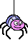


Creating a Filamentality Hotlist

STEP 1

Assemble Resources

- Pick a topic and use a search engine to find 8-10 websites;


http://www.yahoo.com/



http://www.google.com/

http://www.kn.att.com/wired/bluewebn/index.cfm

Cut & paste URL’s into Microsoft Word;

Give each website a title and a brief description.

STEP 2

Filamentality Page

Go to the Filamentality main page;

http://www.kn.att.com/wired/fil/index.html

Click on

STEP 3

Fill in the Blanks
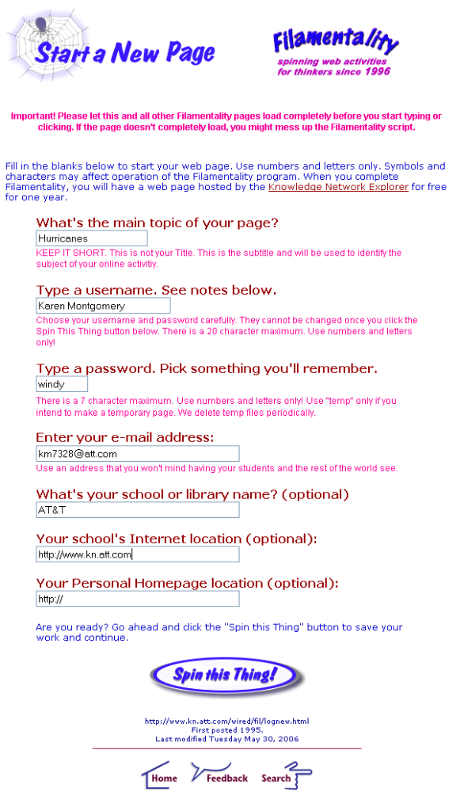

STEP 4

Basic Information
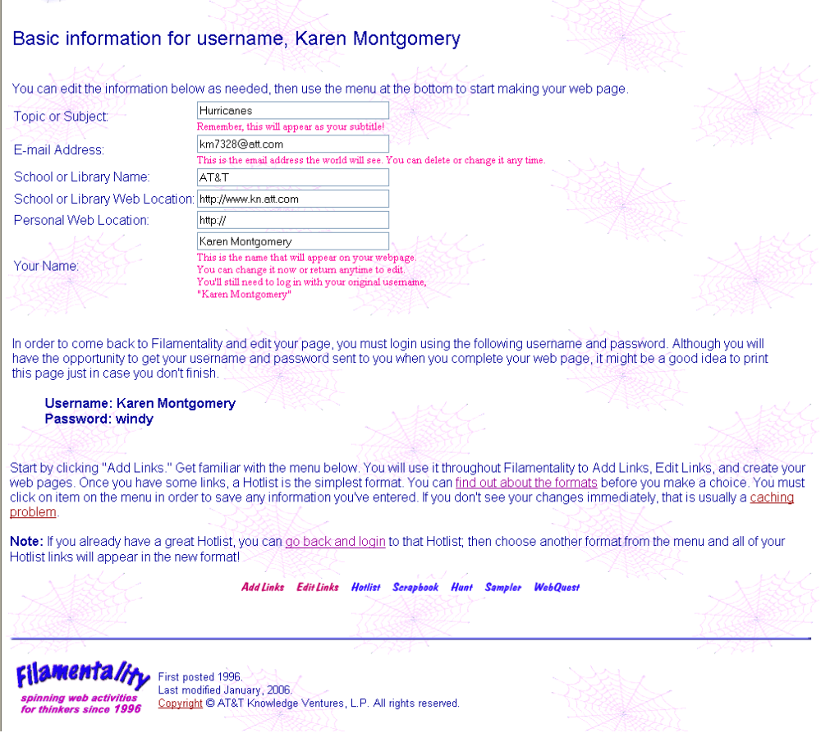

STEP 5

Cut & Paste
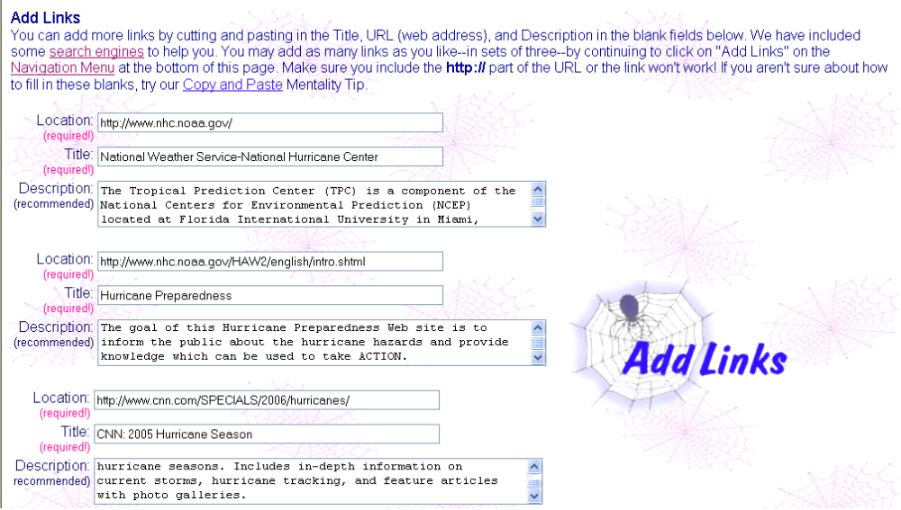

STEP 6

Title & Introduction
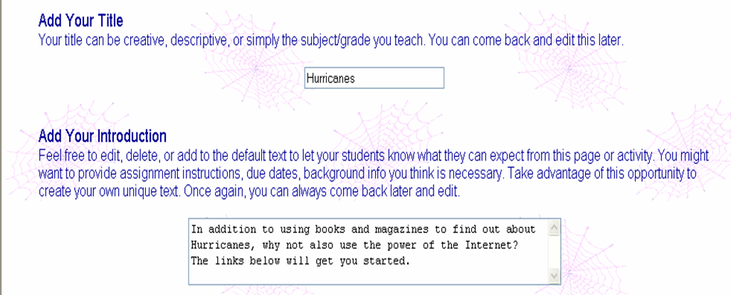

STEP 7

Categorize Links

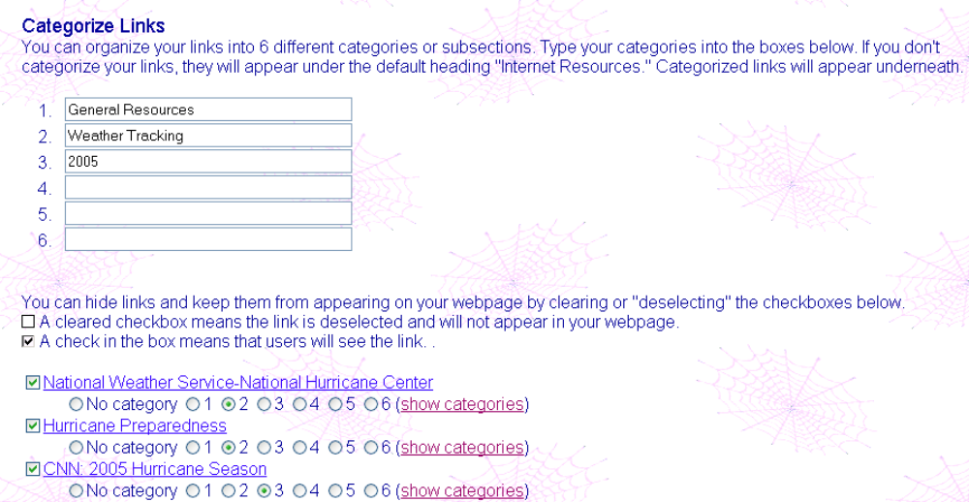

STEP 8

Choose Colors
(Optional)
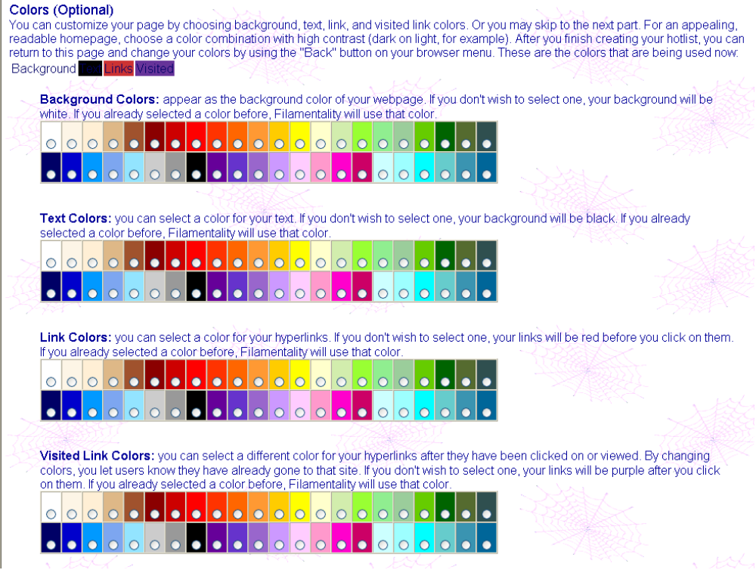

STEP 9

Finish Line
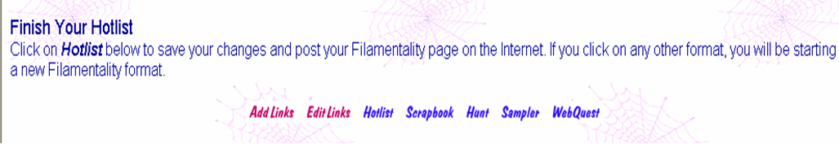

STEP 10

Your URL


